*“Casino Classic Game – Combo 3 in 1 Unity Template” Documentation V2.1*

**“Casino Classic Game”**

*Table of Contents*

1. Description
2. Folder Content
3. Config All Service
4. Android SDK & Java JDK
5. Config Slot Machine Game

**A) Description** -top

Casino Classic Game **–** **Combo 3 In 1** made with Unity, the game consists of 3 games: **Jacks Or Better,** **BlackJack and SlotMachine**. This template has been **optimized for Android and iOS**!

The ZIP package contains the game with resolution that scales to **fit the whole screen device**, even for the **newest devices** like the iPhone XS, **iPhone XS Max** or **SamSung S9…**

Of course, because it was made with Unity you can also build projects for PC, Mac & Linux Standard or

tvOS, XBox, PS Vita, PS 4, WebGL, SamsungTv ...

*Please note, the template has been integrated with all the Plugins: Admob, UnityAds, In-Apps Purchase, Leaderboard, Share Native, Realtime Reward, Local Push. You do not need to re-import any of the above plugins*

**B) Folder Content –** top

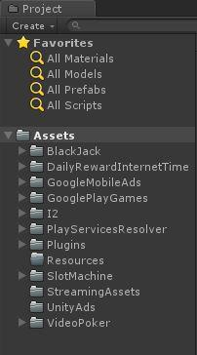

1. **BlackJack:**

The folder contains all script code, animation, image .. with BlackJack game( ready to be edited or reskin).

1. **DailyRewardInternetTime**

Folder contains code for Internet Time Reward.

1. **GoodleMobileAds**

The folder contains a third-party plugin: Admob, for displaying ads.

1. **GoodlePlayGames**

The folder contains a third-party plugin: GooglePlayService, for show ranking( Android).

1. **I2**

This folder contains all mini game : Lucky Wheel.

1. **Plugins**

This folder contains all file needed to build Android and iOS.

1. **Resources**

Empty and to prepare for the next version

1. **SlotMachine**

The folder contains all script code, animation, image .. with SlotMachine game( ready to be edited or reskin).

1. **StreamingAssets**

The folder contains .wav file for sound local push iOS 10. **UnityAds**

The folder contains a third-party plugin: UnityAds, for displaying ads with reward video for freecoins or can skip video ads.

11. **VideoPoker**

The folder contains all script code, animation, image .. with JackOrBetter(or Video Poker) game( ready to be edited or reskin).

1. **Config All Service** -top
   1. **Admob:**

See following video [ConfigAdmob](https://drive.google.com/file/d/1XDRZkT5eFhvI5Ew_TYsFiaFJvTCRxPgP/view?usp=sharing) .

For show Admob Instertial, use method for show this ads:

AdmobBannerController.Instance.ShowInterstitial ();

1. **Unity Ads: :**

See following video [ConfigUnityAds](https://drive.google.com/file/d/1fqFgZeOtgo_Q3oElVfcgkmecLf0asurF/view)

For show UnityAds, use method for show this ads with reward coins:

AdManagerUnity.Instance.ShowAd ("rewardedVideo");

For show UnityAds, use method for show this ads with can skip video ads:

AdManagerUnity.Instance.ShowAd ("video");

**### Choose Network Ads to Show Rewared Video Ads**:

In this project, users can watch rewarded videos to receive coins, you can choose the advertising network : Unity or Admob to show this Rewarded Video Ads. Default is Unity Ads, you can choose Admob following below image.

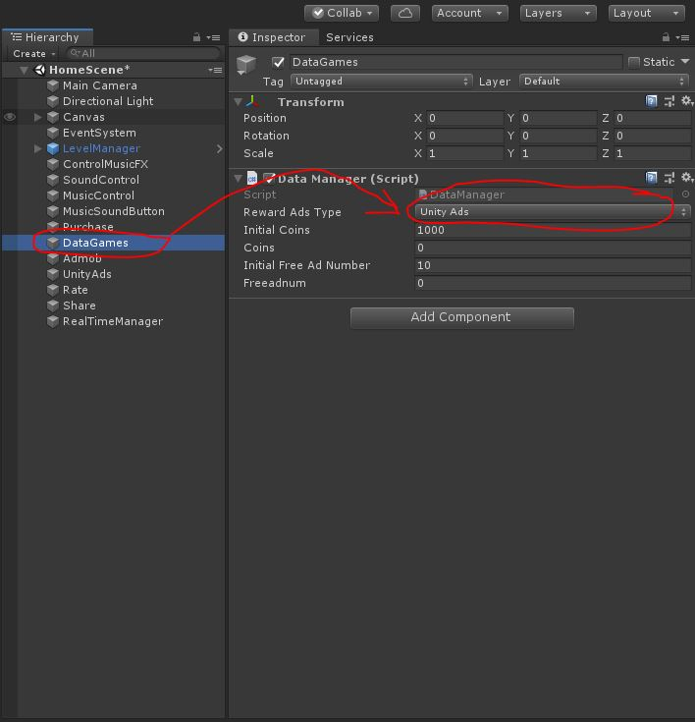

1. **In-Apps Purchase**
   * Step 1: See following video [IAP](https://www.youtube.com/watch?v=509U7CAOZLA) .
   * Step 2: Open **“**Purchaser.cs**”** and change iap id with your id
2. **Time Reward and Local Push**

This is a function on the HomeScene, which allows users to receive free money after a period of time. When the reward is ready, there will be a local push notification to the player



To change the amount received, as well as period of time, select DailyRewardBtn and on the Inspector tab, change the required parameters.

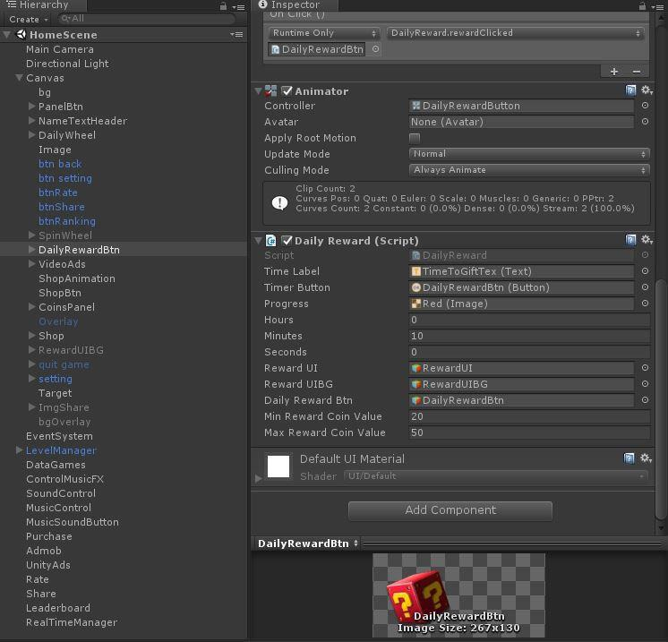

To configure Local Push to match the time, Open **“**DailyReward.cs**”**, in line code 144, change time math the period time.

1. **Rate -** **top**

In Unity Editor, Hierarchy tab, select **“Rate”** object and insert your url to rate

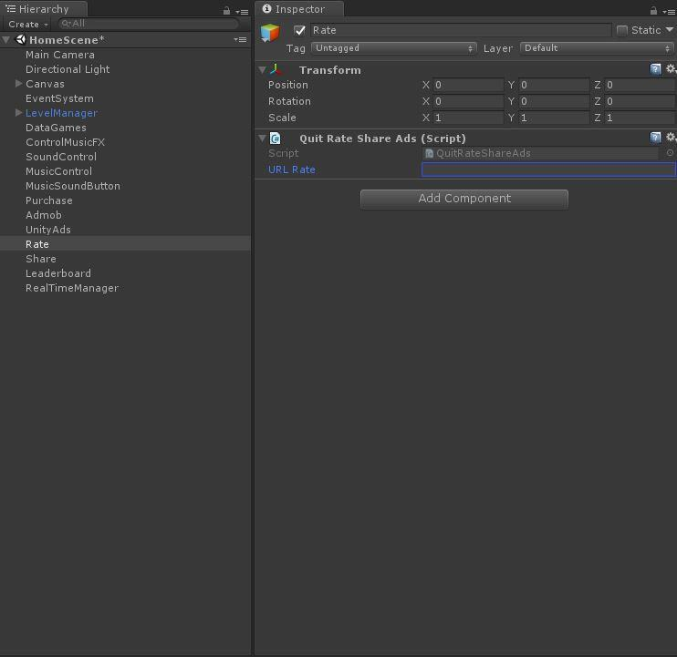

1. **Share**

In Unity Editor, Hierarchy tab, select **“Share”** object and insert your url to share

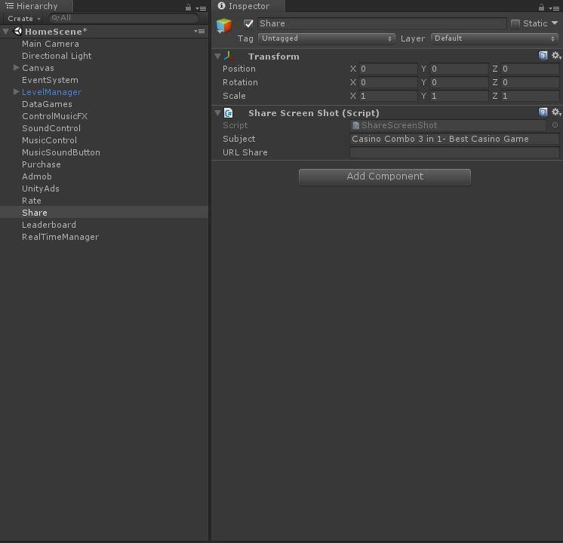

**Android Setup**

* using a ContentProvider requires a small modification in AndroidManifest at **Assets/Plugins/Android**
* inside the <application>...</application> tag of your AndroidManifest, insert the following code snippet:

<provider

android:name="com.yasirkula.unity.UnitySSContentProvider"

android:authorities="MY_UNIQUE_AUTHORITY"

android:exported="false"

android:grantUriPermissions="true" />

Here, you should change **MY_UNIQUE_AUTHORITY** with a **unique string**. That is important because two apps with the same **android:authorities** string in their <provider> tag can't be installed on the same device. Just make it something unique, like your bundle identifier, if you like.

*---------------------------------------*

*----****NOTE******SHARE FOR IOS****-----*

**iOS Setup**

* build your project
* enter a **Photo Library Usage Description** in Xcode (in case user decides to save the shared media to Photos)

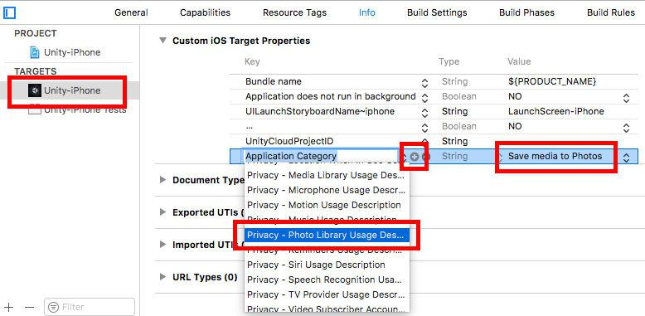

* + also enter a **Photo Library Additions Usage Description**

1. **Android SDK & Java JDK –** top

For Android Build you configure Android SDK path and Java JDK in Unity. The project is built with the following configuration Android SDK and *java jdk1.8.0_131*

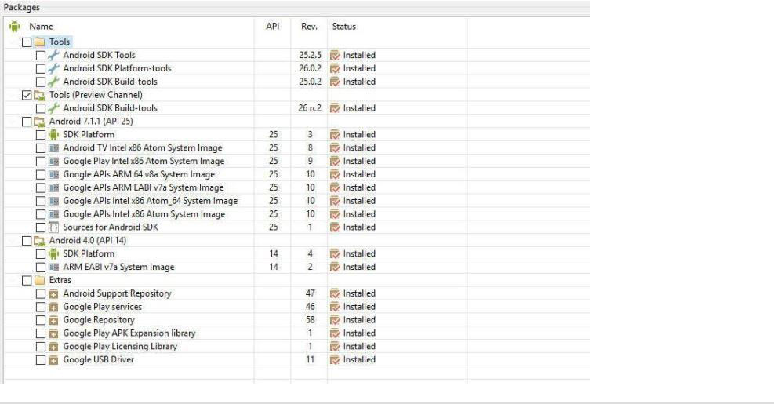

**E) Config Slot Machine Game–** top

1. Edit, create more lines, color lines

1.1. Edit current line:

1.2. Create more lines:

1.3. Custom color lines:

1. Customize the probability of appearing symbols, adding new symbols
2. Change effects, Speed, and more
3. Change value per line, Bet per line

Once again, thank you so much for purchasing this game. Fell free to contact us if you have any questions or issue relating to this game. No guarantees, but we'll do our best to assist.